Filinvest Land Inc. Partners with KMC Community Inc. to Foray into Co-working Business Solutions

Launches Our Space Solutions Inc. (OSSI), Targeting Rise in Co-Working Demand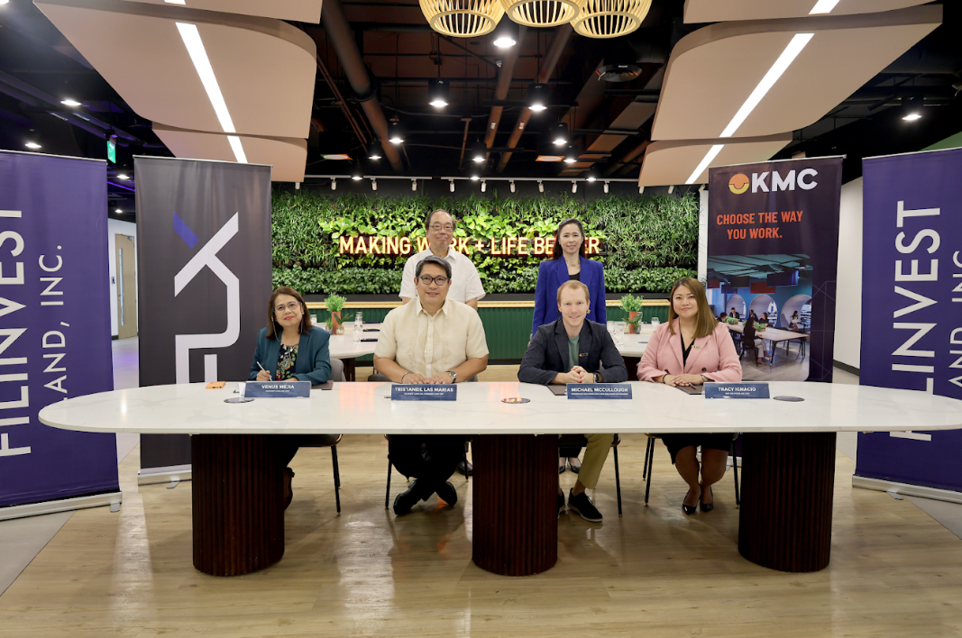
Sitting down from L-R: Venus Mejia (FLI CFO), Tristan Las Marias (FLI President and CEO), Michael McCullough (WorkSpace Solutions CEO and KMC Solutions Inc. Co-founder), Tracy Ignacio (KMC Solutions Inc. COO)

Standing up from L-R: Joseph Yap (FILRT Chairman and Former Ambassador of the Philippines to Singapore), Maricel Brion-Lirio (FILRT President and CEO)
Filinvest City, Philippines – [DATE] – Filinvest Land Inc. (FLI), a leading Philippine developer, and KMC Community Inc. (KMC), a global co-working space provider, announced the launch of their joint venture company, Our Space Solutions Inc. (OSSI).
This strategic partnership signifies a major step in catering to the growing demand for co-working spaces in the Philippines. The first OSSI locations are situated in Axis Tower One, a prime office building within Filinvest City's Northgate Cyberzone.
A Collaboration to Meet Evolving Workplace Needs
The joint venture agreement (JVA) between FLI and KMC entails the establishment, operation, development, management, and maintenance of flexible workspaces. This includes offering private serviced office seats and co-working arrangements within commercial buildings across the Philippines.
"The rise of remote work has significantly reshaped the landscape of office spaces," shared Tristan Las Marias, President and CEO of Filinvest Land Inc. "Our partnership with KMC, a recognized leader in the co-working industry, allows us to address this growing demand with innovative and adaptable solutions under the Our Space Solutions Inc. brand, and further provides alternate rental solutions to improve occupancy of FLI and FREIT office spaces."
KMC's Expertise Meets FLI's Local Strength
KMC brings its extensive experience in designing and managing vibrant co-working communities to the table. Michael McCullough, CEO for WorkSpace Solutions and Co-founder, expressed his enthusiasm: "We are thrilled to be partnering with Filinvest Land Inc. to introduce OSSI. By combining KMC's global network and expertise with FLI's established presence in the Philippine market, we are confident that OSSI will become a leader in the co-working space industry here."
A Valued Partnership for Filinvest Land and Filinvest REIT Corp.
OSSI is currently a locator in Filinvest REIT’s Axis tower One in Filinvest City, Alabang and is looking at opening more co-working spaces in Filinvest Land’s Makati, Quezon City, and Pasig City office properties.
Maricel Brion-Lirio, President and CEO of Filinvest REIT Corp., the company that owns Axis Tower One, commented, "We are delighted to welcome OSSI as a valued locator at Axis Tower One. This innovative partnership perfectly complements the dynamic and forward-thinking atmosphere we strive to cultivate within our office buildings."
The launch of OSSI signifies a significant development in providing flexible and collaborative workspaces for Filipino businesses and professionals, particularly with the increasing adoption of remote and hybrid work models.
***
About Filinvest Land and Filinvest REIT Corp.
Filinvest Land, Inc. (FLI), a subsidiary of Filinvest Development Corporation (FDC), is one of the country’s leading and multi-awarded full-range property developers. It is listed on the Philippine Stock Exchange under the trading symbol $FLI. Staying true to its mission, FLI continues to build the Filipino dream across the Philippines.
For over 60 years, FLI has built a diverse project portfolio spanning the archipelago, from its core best-value homes to residential townships, mid- and high-rise condominiums, office buildings, shopping centers, industrial parks, co-living properties, and leisure developments.
These include the large-scale townships: Havila (306 hectares), Timberland Heights (677 hectares), and Manna East (60 hectares) in Rizal; Ciudad de Calamba (350 hectares) in Laguna; Palm Estates (51 hectares) in Talisay City, Negros Occidental; and City di Mare, the Lifestyle Capital of Cebu (50 hectares).
FLI owns 20% of Filinvest Alabang, Inc., developer of Filinvest City (244 hectares), South Metro Manila’s premier garden central business district and home to Festival Mall, the flagship Filinvest Mall in Alabang. FLI is also developing two townships in the Clark Freeport Special Economic Zone: the industrial Filinvest Innovation Park-New Clark City (288 hectares) and Filinvest Mimosa+ Leisure City (201 hectares), the former in partnership with BCDA, and the latter in partnership with FDC.
Filinvest REIT Corp. (FILRT) is the country’s first sustainability-themed real estate investment trust (REIT) backed by Filinvest Land Inc. (FLI), one of the largest property developers in the Philippines with an established portfolio of residential, commercial, industrial, and office developments across the archipelago.
Its commercial portfolio consists of 17 Grade A office buildings that provide world-class, eco-friendly workspaces for local and global businesses. Recognized by Jones Lang Lasalle (JLL) for its green and sustainability-themed features, FILRT’s office buildings portfolio is designed to meet the evolving needs of today's businesses while reducing environmental impact. Totaling over 300,000 square meters of gross leasable area (GLA), 16 of the buildings are in Northgate Cyberzone – an IT BPO campus-style hub accredited by the Philippine Economic Zone Authority (PEZA) in Filinvest City, Alabang. Filinvest City is a 244-hectare mixed-use and integrated city that is the first and only central business district (CBD) in the Philippines to receive LEED® v4 Gold for Neighborhood Development Plan certification as well as a three-star BERDE certification. Two of the FILRT properties in Filinvest City, namely Axis Tower One and Vector Three, are among the country’s few LEED Gold certified developments. Another building is Filinvest Cyberzone Cebu Tower 1 located in the gateway of Cebu IT Park in Lahug, Cebu City. Rounding up the portfolio is 2.9 hectares of land that is being leased to the owner and operator of multi-awarded Crimson Resort & Spa Boracay.
As the future of responsible workspaces, Filinvest REIT is leading the way in sustainable real estate movement.

